Rhetoric and the Rhetorical Situation

Rhetoric
  - the study, uses, and effects of written, spoken, and visual language (Rhetoric and Writing Studies, San Diego State University)
  - the study of the effective use of language
  - the ability to use language effectively
  - the art of influencing the thought and conduct of an audience (dictionary.com)

The Rhetorical Situation

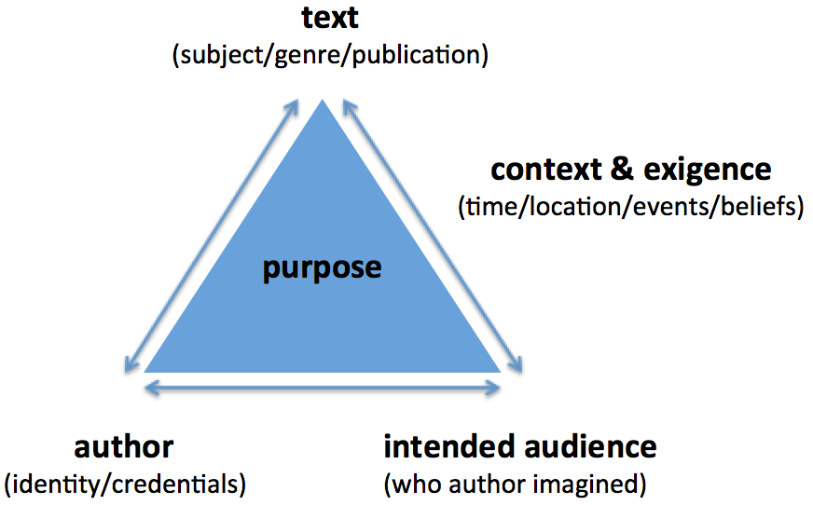 | - writer- age, experience, profession, gender, locations, political beliefs, education, etc.  - text - subject (broad, narrow), genre (poem, essay, narrative, speech, etc.), publication (newspaper, book, website, journal, etc.)  - intended audience – audience of the publication and/or that the writer imagined (consider age, experience, profession, gender, locations, political beliefs, education, expectations, etc.)  - purpose- to persuade, entertain, inform, educate, call to action, shock, etc.  - context and exigence – the “situation” which generates need/urgency is writing; time, location, current events, cultural significance

Argument, in the context of rhetorical study, does not refer to a situation in which people are fighting. Rather, argument refers to a situation in which a writer is making a case for a way of seeing things—to feel, consider, believe, or do something. It is a conclusion or claim based on evidence. For any piece of language (written, spoken, or visual) designed to bring about some change in a reader’s, listener’s, or hearer’s ideas or attitudes, we can consider these texts arguments.

Evidence is the support, reasons, data or information used to help persuade an audience of an argument. To find evidence in a text, ask yourself: What does the author have to go on? What evidence is there to support this claim? Is the evidence credible? Types of evidence include scientific facts, historical examples/comparisons, (hypothetical) examples, analogies, illustrations, statistics (source & date are important), charts/graphs, expert testimony, citing authorities, anecdotes, witnesses, personal experiences, reasoning, etc.
